EVENTS APP

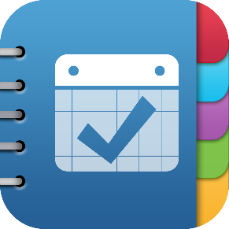

Naman Goyal (2015CSB1021)

Sarthak Gupta (2015CSB1029)

Vishal Singh (2015CSB1040)

Nittin Singh (2015CSB1067)

Supervised By

Dr. Neeraj Goel

Dr. Mukesh Saini

Indian Institute of Technology Ropar

# Project

App Installation Link

<http://10.1.1.19/~2015csb1021/events.apk>

Project Android Application Repository

<https://github.com/namangoyal6/eventsapp>

Project Server and API Repository

<https://github.com/namangoyal6/csp203>

Project Website

<http://10.1.1.19/~2015csb1021>

Feedback Link

<https://goo.gl/O4wpGg>

# Aim

To ease students' stay at IIT Ropar, and provide one click access to all relevant updates at the institute.

# Features

Know about ongoing events, conferences, talks, seminars - Cultural, Technical, Sports, Seminar etc.

* Add new events
* Update Existing events
* Add Reviews
* Notify events based on your interest

# App Description

The App provides an easy solution for creating events and notifying all concerned.

## Login/Register

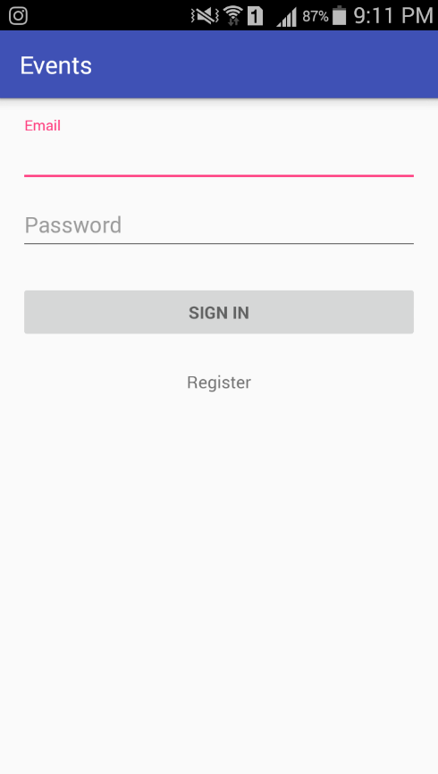After Installation open the app. The first page is the Login-Activity.

Existing user can enter his/her email and password to SIGN IN.

Being first time user. Click on Register button.

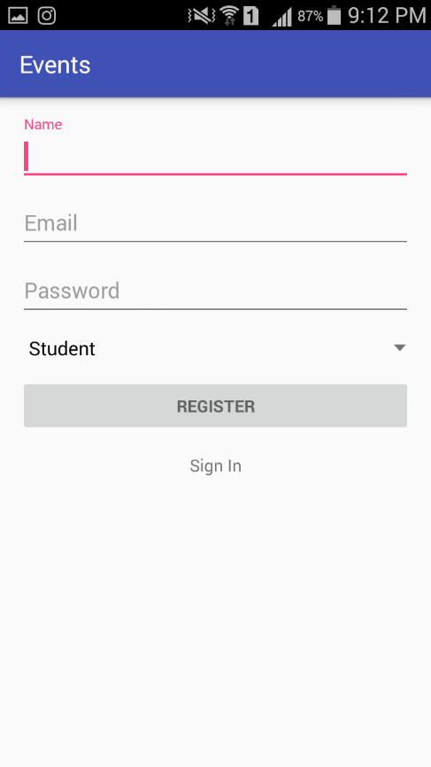After clicking on Register button, new activity opens.

Enter your Name, Email and Password.

(Email should be of type <xyz>@iitrpr.ac.in).

Password should be at least 8 characters long.

Choose your category.

Click on REGISTER.

Message appears declaring successful registration.

After this you are directed to the Login-Activity.Now enter your credentials and click SIGN IN.

## List Events

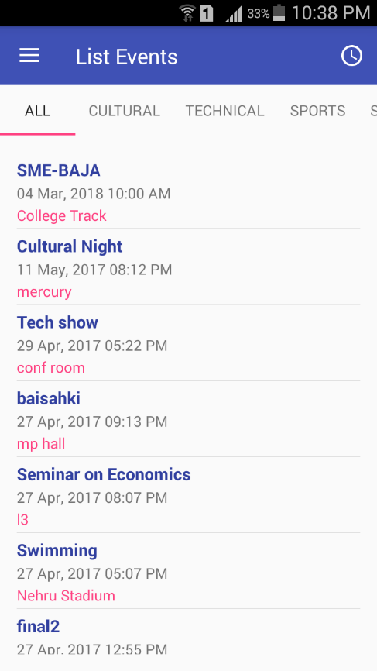This Activity contains the list of all events which are visible* to user.

Also the events are listed according to their types* as well.

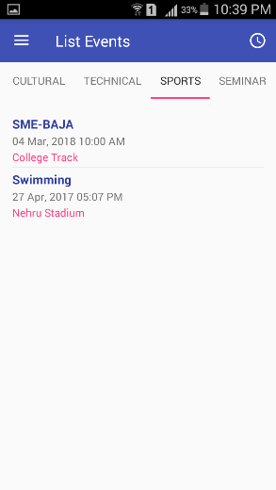 Cultural: Technical: Sports:

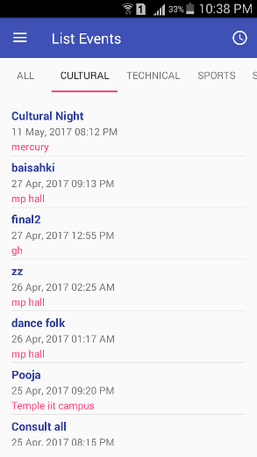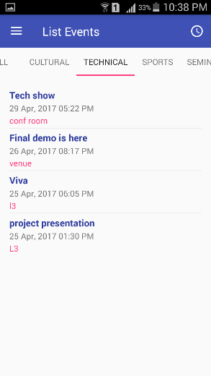

## Event Display

Click on any event you are interested in: for instance

*‘Cultural Night’*

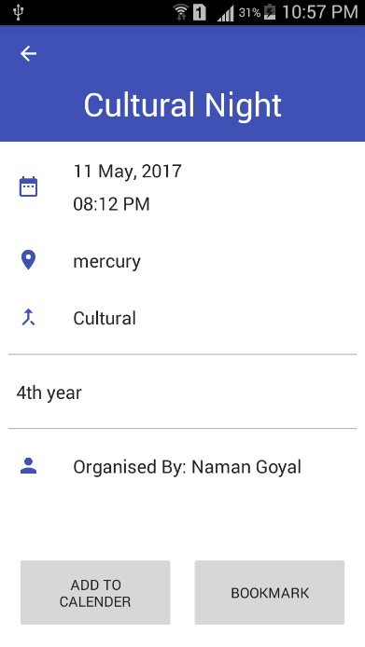This activity displays the necessary info related to the event.

You can *‘BOOKMARK’* this and get this event enlisted as your bookmarks, so you can later on decide what to do.

Or you can ‘*ADD TO CALENDER’* this would set a reminder on your device.

## Add to Calendar and Bookmark

*‘ADD TO CALENDAR’* looks for any calendar app installed in the device.

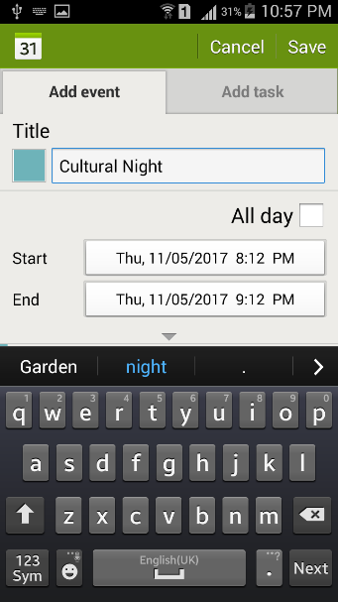There the user can add events to his calendar, and *‘BOOKMARK’* to add favourites in the App.

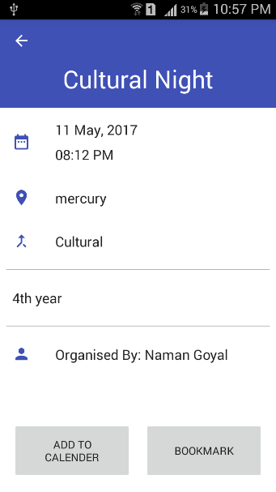

## Past Events

**Click here this opens this *Nav-bar*.**

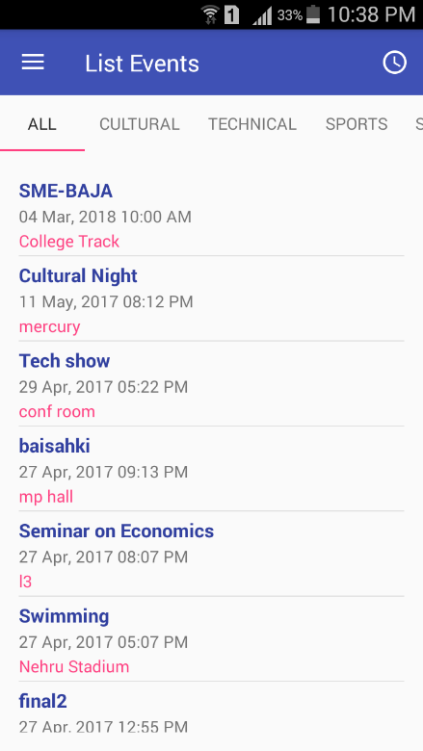

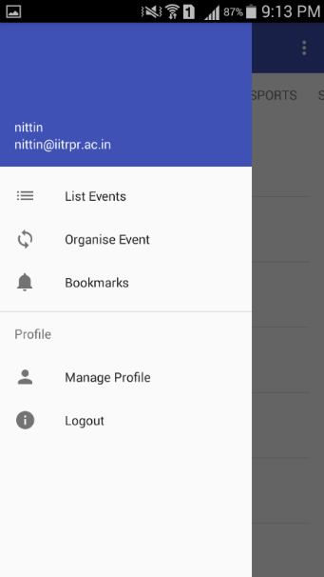

**Click here for List of past Events.**

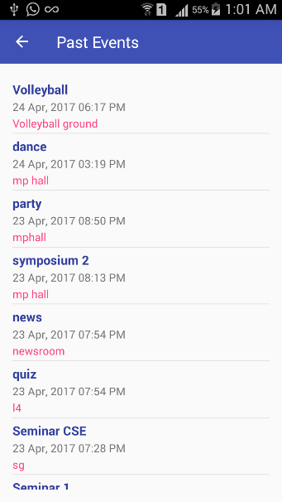

## Navigation Bar (Nav-Bar)

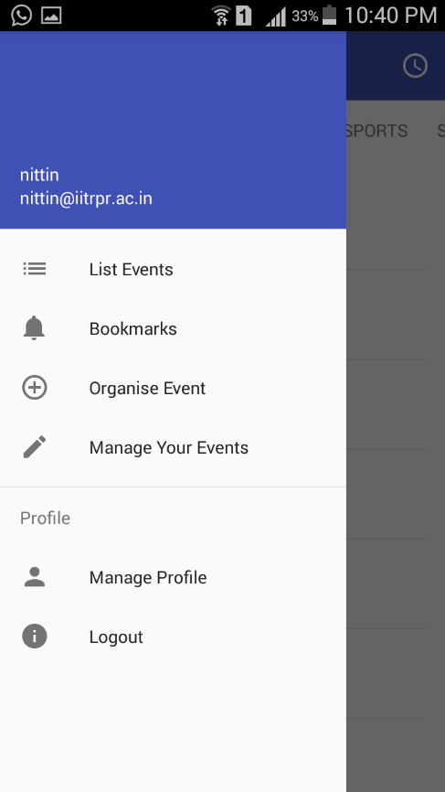

This button redirects you to the *List-all* activity.

This button takes you to the Organise Event Activity.

This button takes you to list of all bookmarks you have created.

This button helps in making any changes to Events that you have organised.

This button takes user to his/her profile

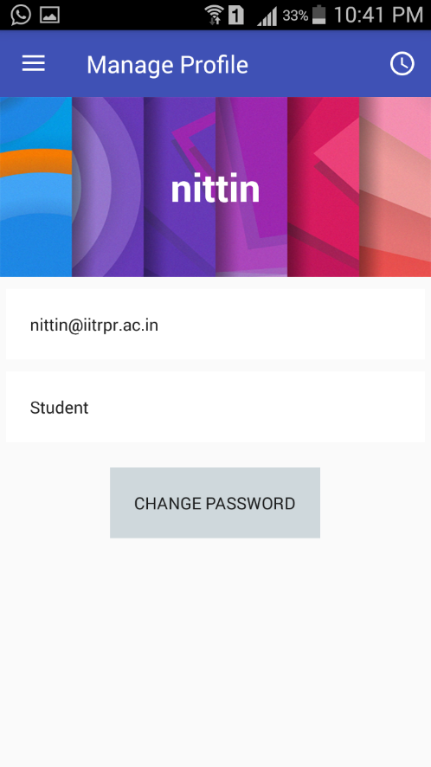

User can change his/her password.

This button logs out the user, the user is directed to the login-activity.

## Organise Event

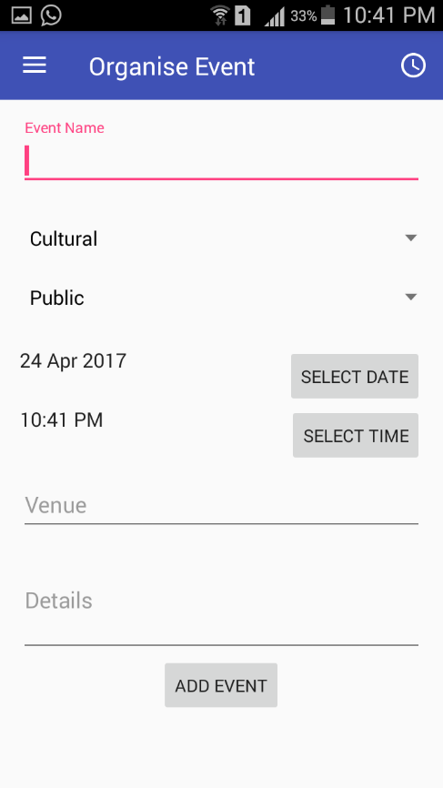This activity opens on clicking the Organise Event Button.

The user can add/create event of his/her own interest.

Category/type can be chosen from the options.

Next step is to decide the visibility of events:

Public 🡪 visible to all.

Rest 🡪 Visible only to that category.

Date and Time should be of future, or else it won’t be displayed on the list.

Venue and Details should be provided by organiser.

Click on ‘ADD-EVENT’. For instance, consider an event ‘ISMP Meeting’ being created.

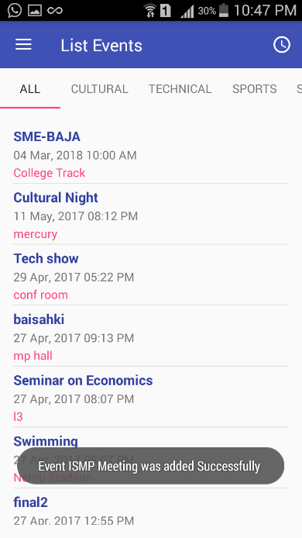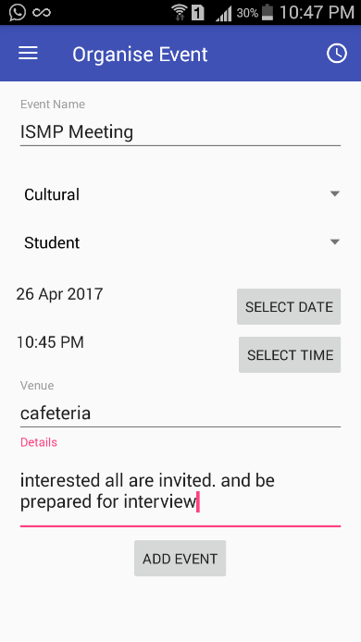

This creation of new event sends a notification to all the concerned.

## Notification of New Event

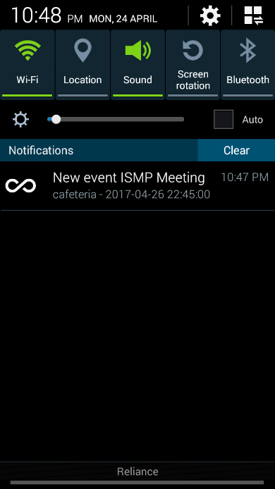Click on the notification. It opens the event and gives option of bookmarking or adding to the calendar.

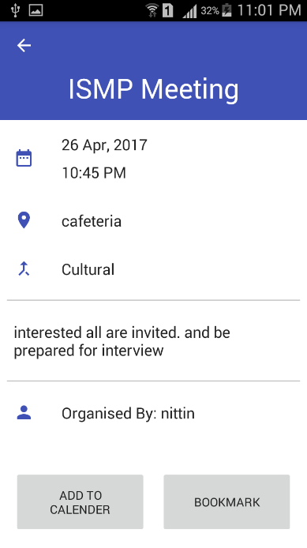

## Manage Your Events

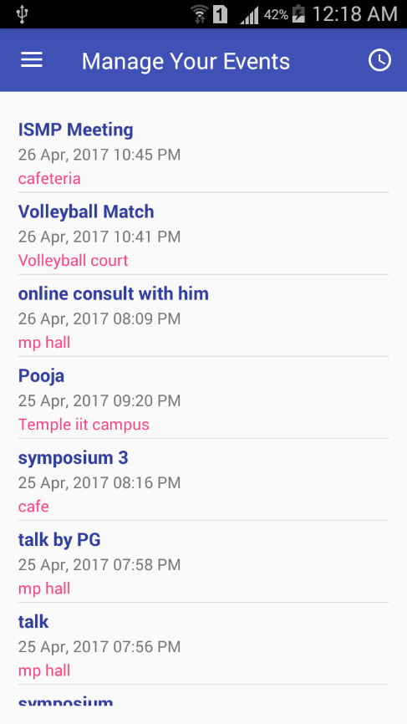

Click on:

*‘Manage Your Events’*

This displays all the events you have organised till now.

## Update Organised Event

Choose whichever event you want to Edit; Suppose we want to change details of ‘Pooja’; Click on ‘Pooja’:

This opens the Edit Organised Event Activity:

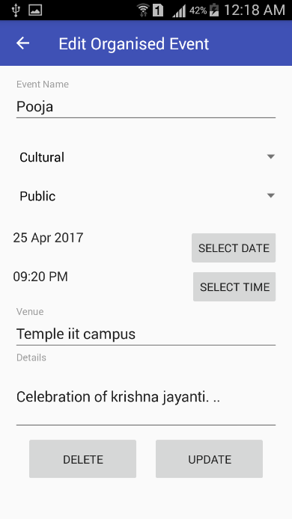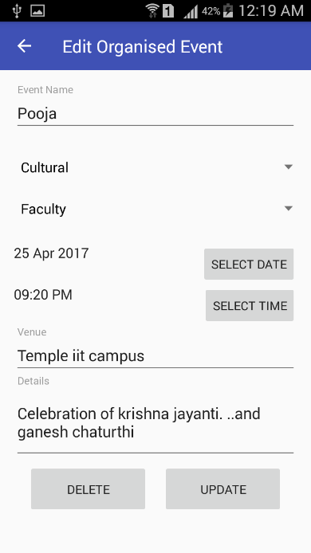Make necessary changes.

As shown:

Click on *‘UPDATE’* button, this updates all the changes you have made and a notification is sent to all the concerned.

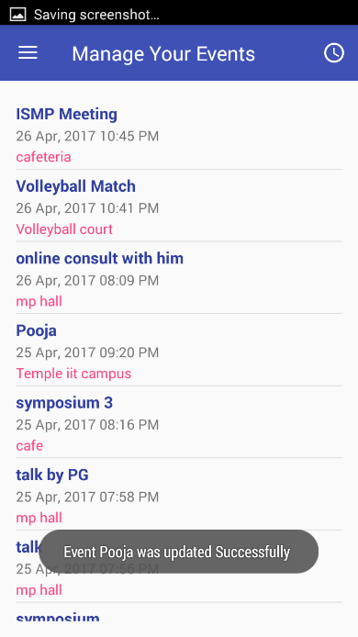

## Delete Organised Event

In case the organiser wants to delete his/her organised event. He/She can simply go to the Edit Organised Event activity and Click ‘DELETE’.

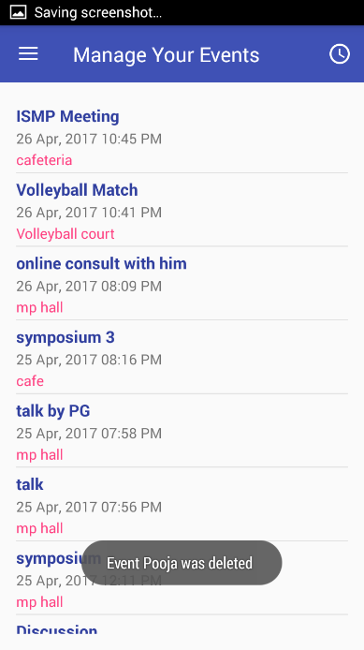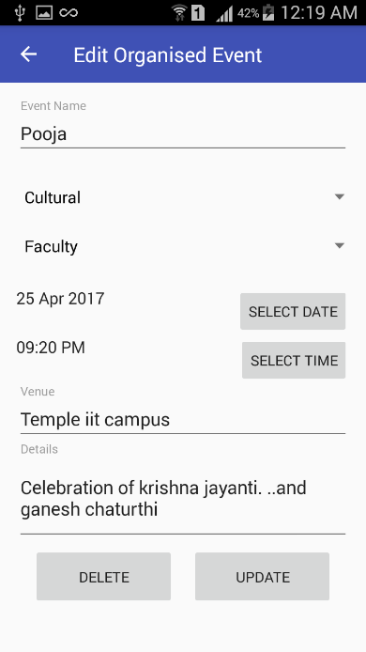

Click On ‘DELETE’

and the event is permanently deleted.

# Server

The Server consist of

## MYSQL Database

Various MySQL tables store information like

* User Registration
* Events
* Categories
* User types
* Bookmarks
* Firebase Registration Token

## Firebase - Mobile App Platform

Firebase provides various functionalities like

* Analytics
* Notification Management
* User groups and Topics Management

# API

Application programming interface consist of

## PHP Scripts

Various PHP Scripts help query MySQL using GET and POST Methods.

To implement notification creation background processing is used to save user load time.

## Firebase Could Messaging

Firebase Cloud Messaging help sending notification by managing user devices in user groups called topics.

The topics a user is join is

* Broadcast – Public
* Specific user topic for Student, Staff and faculty.

This helps in achieving sending targeted notifications and broadcasts.

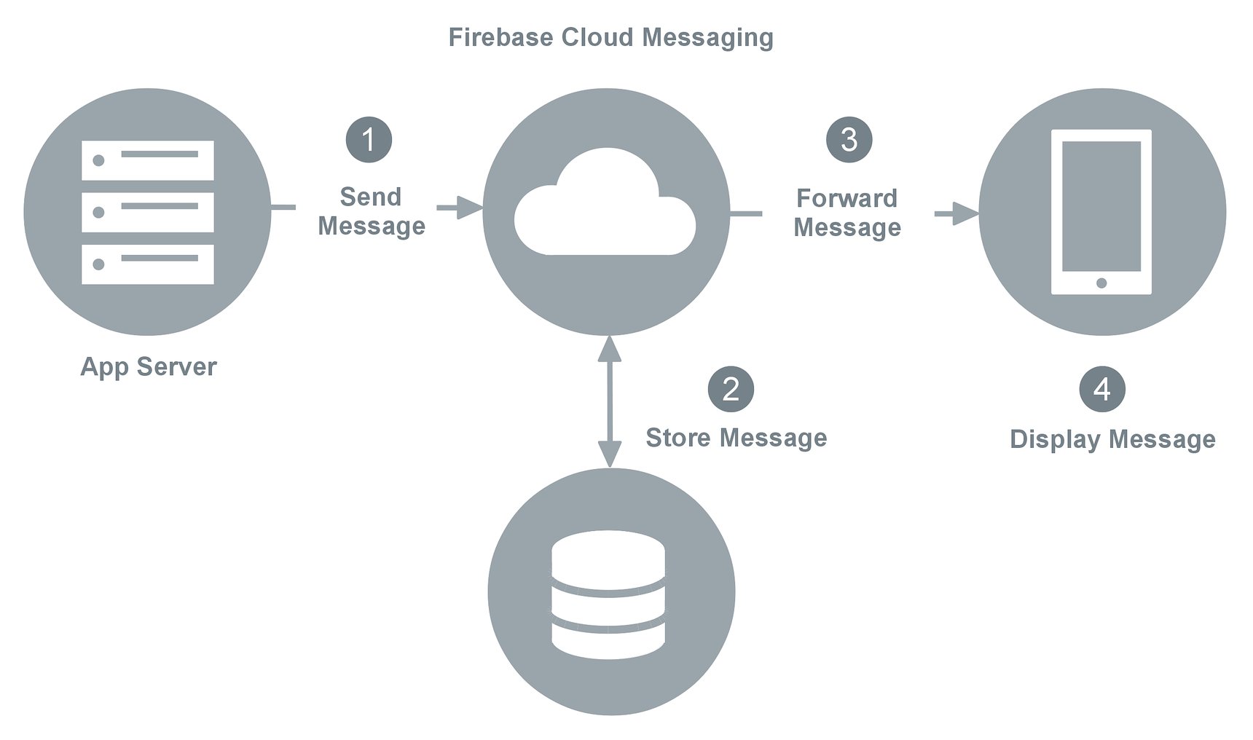

# Further Scope

The app has a lot of scope for extension. Below are listed some of them.

* Recommend events based on User engagement and preferences
* Support for Wider audience by allowing users to create groups.
* Integration of Firebase for User Authentication.
* Allowing for rating of events and provide user with sorting options.